**Introducing Logisim**

Welcome to Logisim!

Logisim allows you to design and simulate digital circuits. It is intended as an educational tool, to help you learn how circuits work.

**Environmental Layout:**

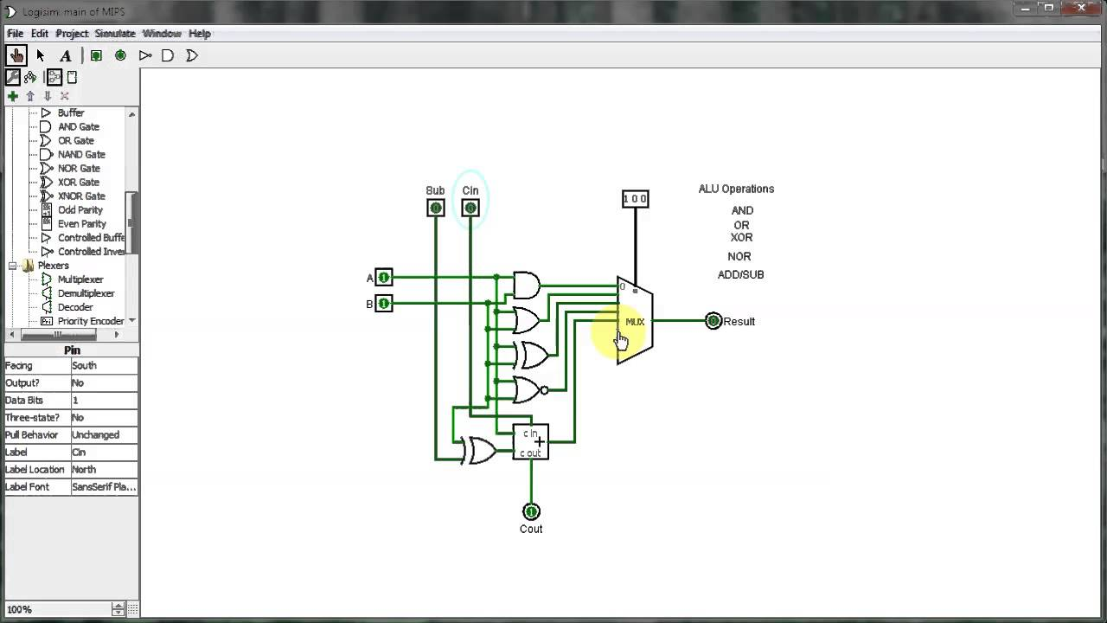

* **Toolbar:** The toolbar contains short cuts to several commonly used items

**–** The *poke tool* (shaped like a hand) is used to alter input pins.  
**–** The *input pin* (green circle surrounded by a box) is used to send a signal through a wire. When placing the input on the canvas it initializes to 1-bit. This number of bits can be increased in the Attribute Table.  
**–** The *output pin* (green circle in a circle) is used to observe output from a gate. The output pin toggles in real time as long as the simulation is enabled from the menu bar Simulate *>* Simulate  
enabled

*•* **Explorer Pane:** The list of wiring, gates, multiplexers, etc... that are available for digital design in  
Logisim. Please note not all items are allowed to be used in every project.  
*•* **Attribute Table:** Gives detailed attributes of digital design components (e.g., AND, OR, XOR  
gates). The attribute table allows you to alter the number of inputs/outputs that a digital design  
component.  
*•* **Canvas:** The canvas is the area for you to create your digital circuits. In the canvas area you may  
simulate your circuits while designing in real time.

To practice using Logisim, let's build a XOR circuit - that is, a circuit that takes two inputs (which we'll call *x* and *y*) and outputs 0 if the inputs are the same and 1 if they are different. The following truth table illustrates.

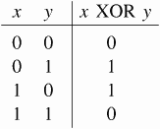

We might design such a circuit on paper.

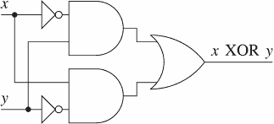

But just because it's on paper doesn't mean it is right. To verify our work, we'll draw it in Logisim and test it. As an added bonus, we'll get a circuit that's looks nicer than what you probably would draw by hand.